Apollo is a major English training system in the world. The system has a lot of centers and a lot of students studying. To manage student learning, Apollo uses the network to manage student information as well as the courses students attend. Each student when enrolling in Apollo system will be granted an account on the system to be able to use the resources of available books and videos. In addition, students can also take proficiency tests

on the online system. After the students take the online tests, the center's teachers will judge and evaluate these tests. Then

the teacher will have instructions for students to improve their shortcomings.

The manager of Apollo is very concerned about the current information system and has met with various senior staff and it has been decided that a new information system is required

Biểu đồ usecase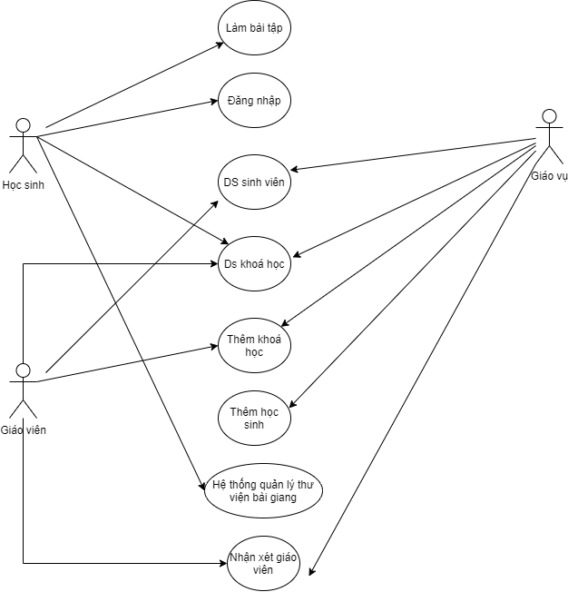

Trang chủ

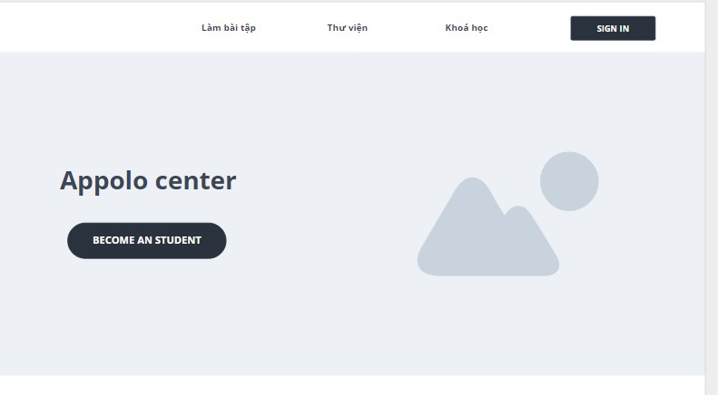

Đăng nhập

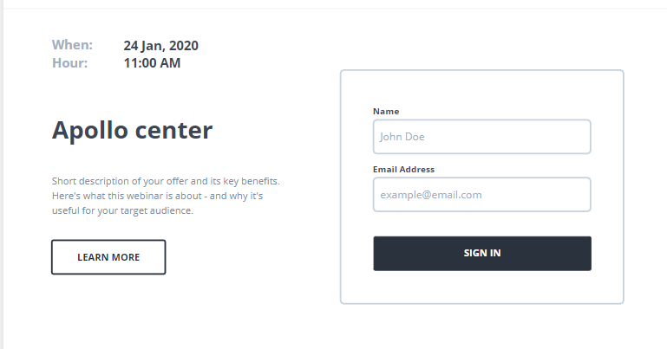

Danh sách học sinh

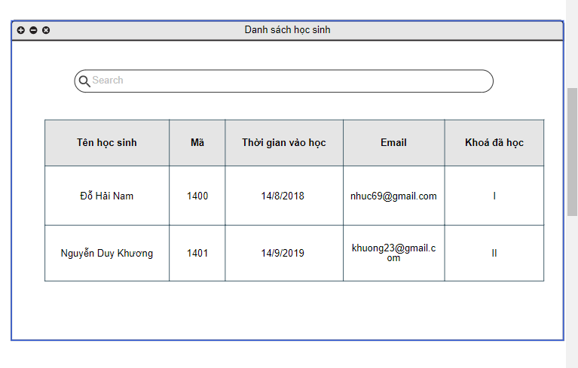

Thêm học sinh

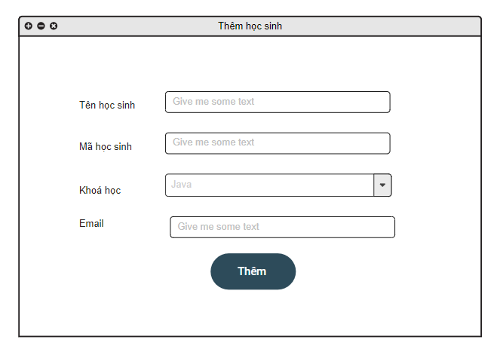

Danh sách khoá học

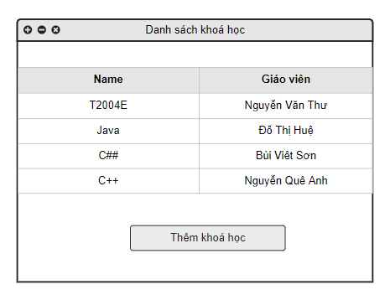

Thêm khoá học

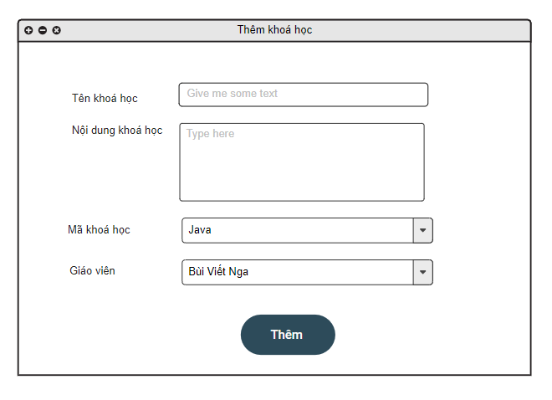

Thư viện tư liệu bài giảng

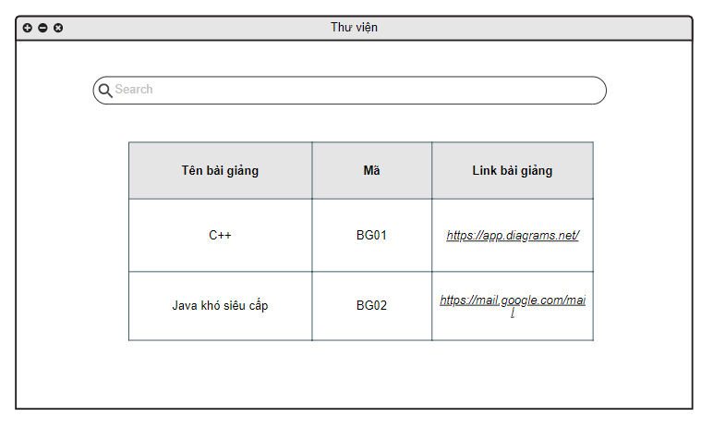

Làm bài tập

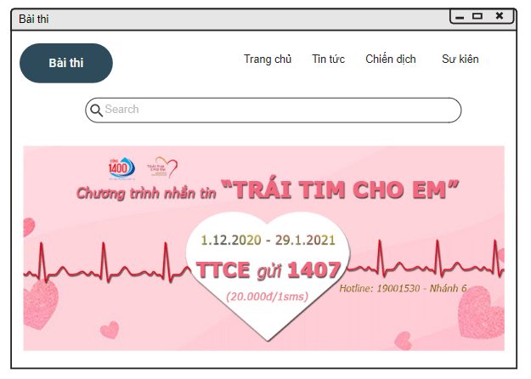

Nhận xét giáo viên